Stu 1.ID: 21219109 Name 1: Quentin Springer
Stu 2.ID: 21290294 Name 2: Charlotte Christine Thøgersen Rosén

Answer Sheet
Lab 5: Motor Speed and 2 DC Motors Direction Control
Task 1 – Control the speed of rotation in one DC motor

Screenshot of A and B plot with PWM duty cycle 0% :

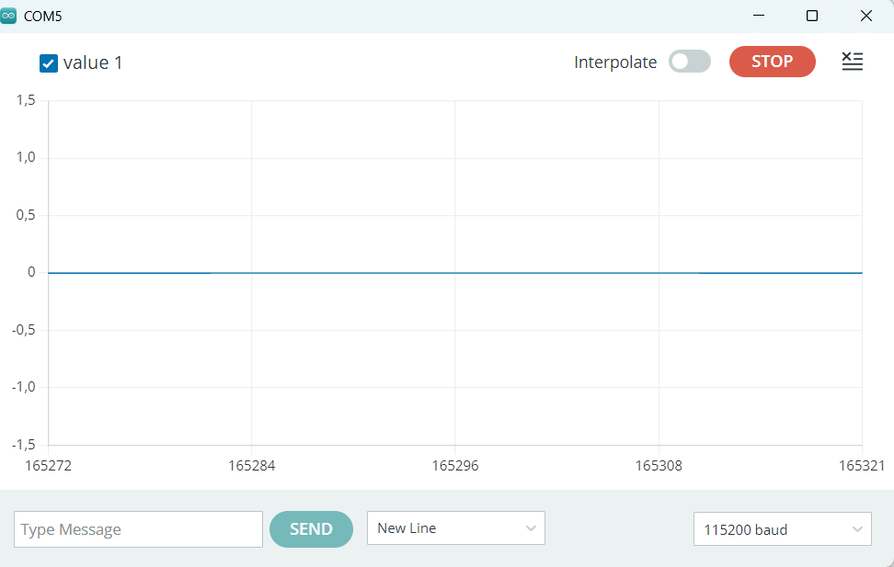

Screenshot of A and B plot with PWM duty cycle 25% :

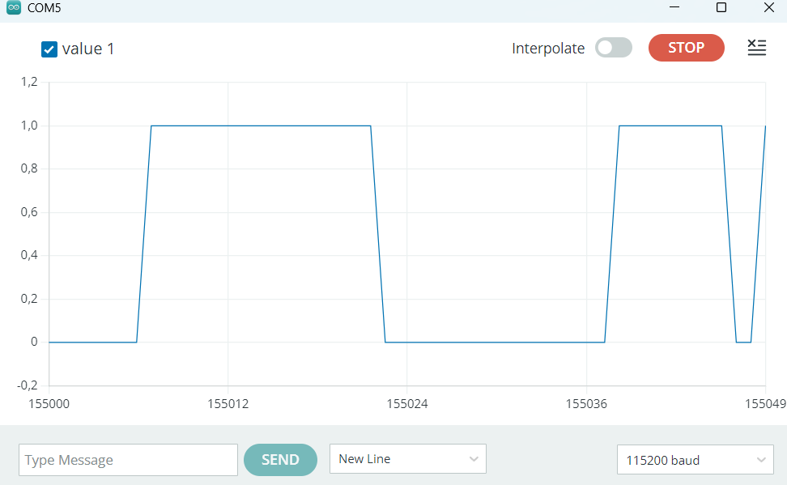

For small duty cycles, the motors might not spin, and make a continuous buzz sound.

Screenshot of A and B plot with PWM duty cycle 50% :

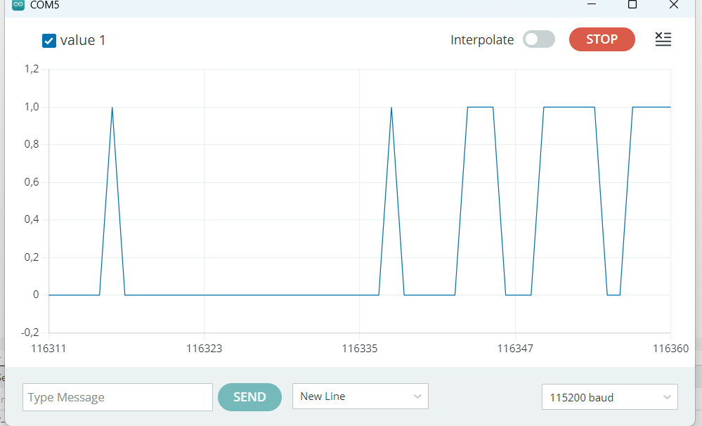

Screenshot of A and B plot with PWM duty cycle 75% :

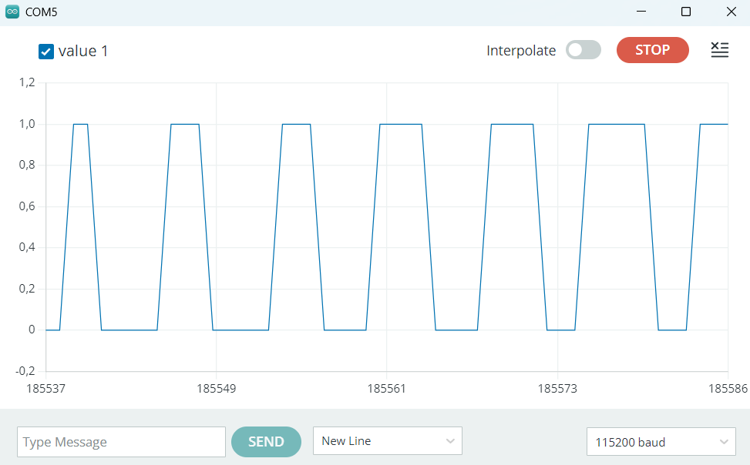
Screenshot of A and B plot with PWM duty cycle 100% :

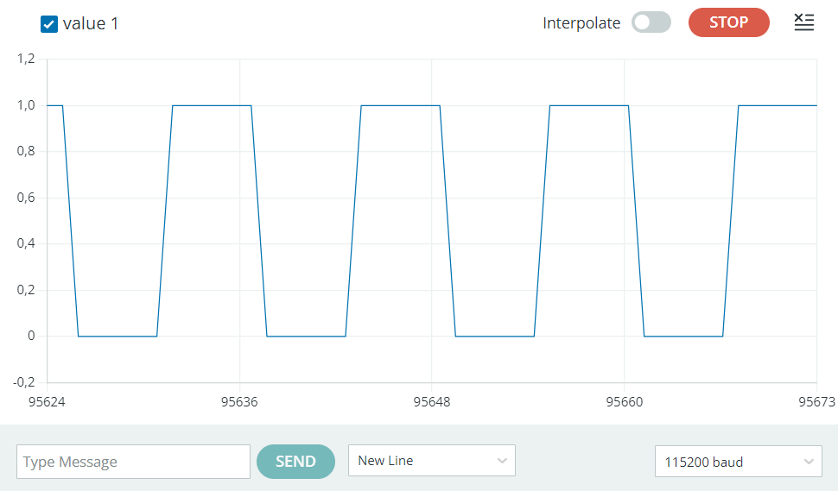

The motor model you used is CHR-GM25-370

Please paste the code you wrote to set a rotation direction below.
digitalWrite(IN1, LOW);
digitalWrite(IN2, HIGH);

Your motor resulting rotation direction is B
- 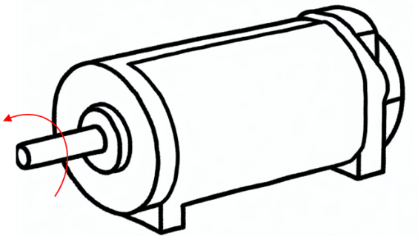 B. 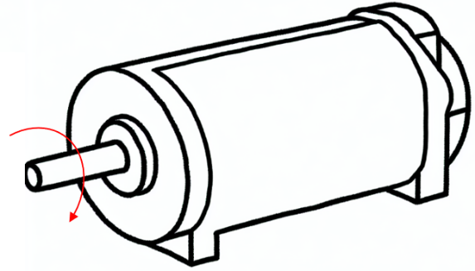

BONUS:
Screenshot of A and B plot with PWM duty cycle 0% :

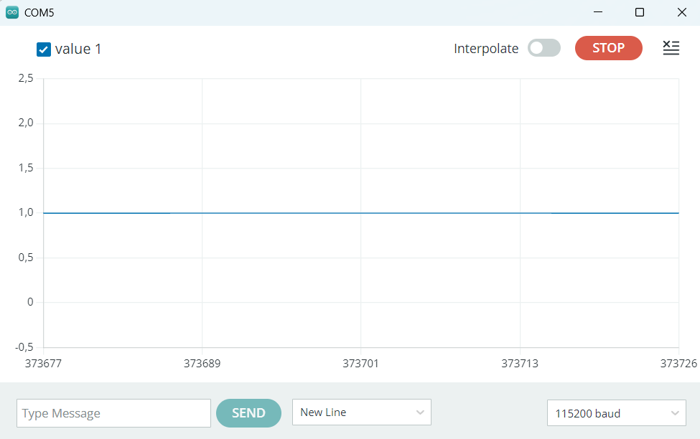
Screenshot of A and B plot with PWM duty cycle 25% :

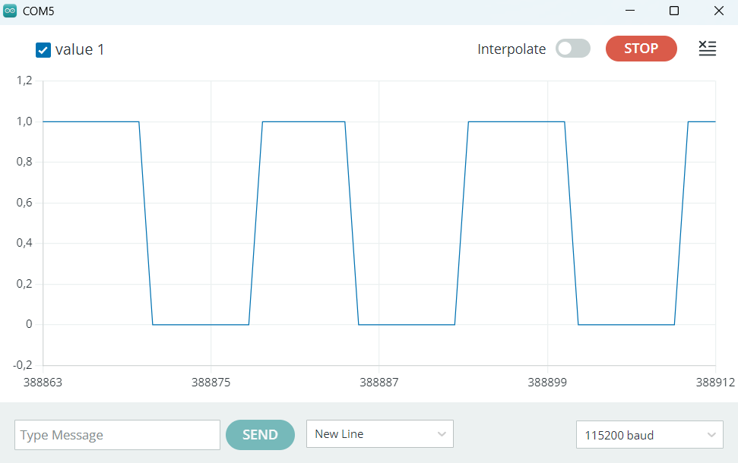

Screenshot of A and B plot with PWM duty cycle 50% :
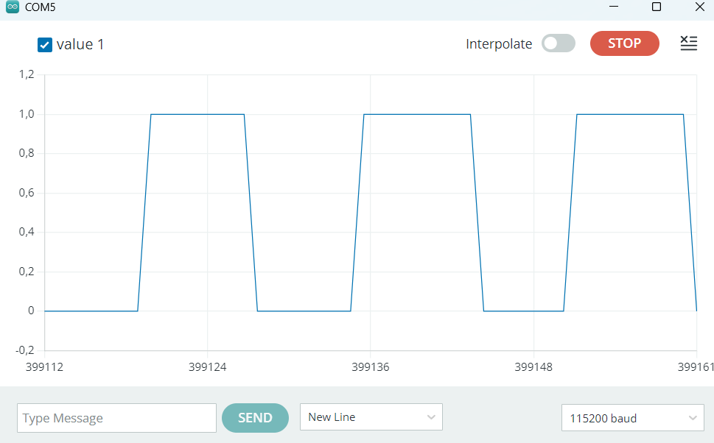

Screenshot of A and B plot with PWM duty cycle 75% :
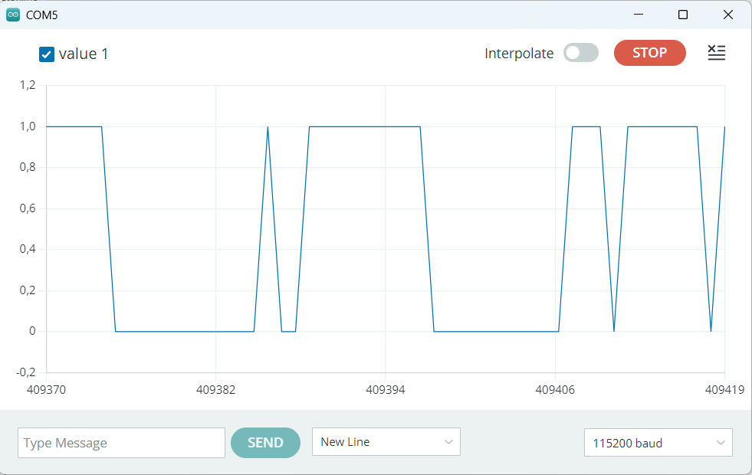
Screenshot of A and B plot with PWM duty cycle 100% :

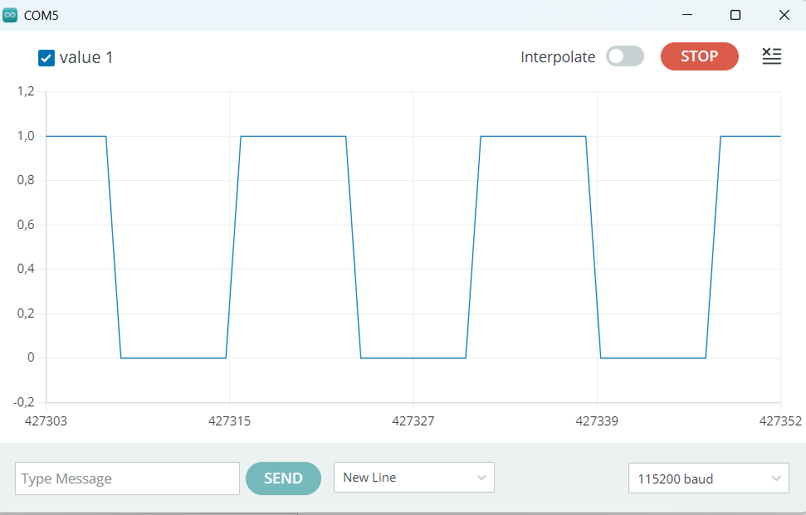

The motor model you used is CHR-GM25-370

Please paste the code you wrote to set a rotation direction below.

digitalWrite(IN1, HIGH);
digitalWrite(IN2, LOW);

Your motor resulting rotation direction is A
- B.

Task 2 – Control the direction of 2 DC motors
Please complete the following Table. 2 in the answer sheet that outlines the state combinations for IN1, IN2, IN3, and IN4 corresponding to the robot's movements, based on Table 1. Motor L is positioned on the left and is connected to IN1 and IN2, while Motor R is positioned on the right and connected to IN3 and IN4.
Table. 2 The state combinations for IN1, IN2, IN3, and IN4 corresponding to the robot's movements
 | IN1 | IN2 | IN3 | IN4
Forward | HIGH | LOW | LOW | HIGH
Backward | LOW | HIGH | HIGH | LOW
Right | HIGH | LOW | LOW | LOW
Left | LOW | LOW | LOW | HIGH
Stop | LOW | LOW | LOW | LOW

Screenshot of plots of moving Forward:

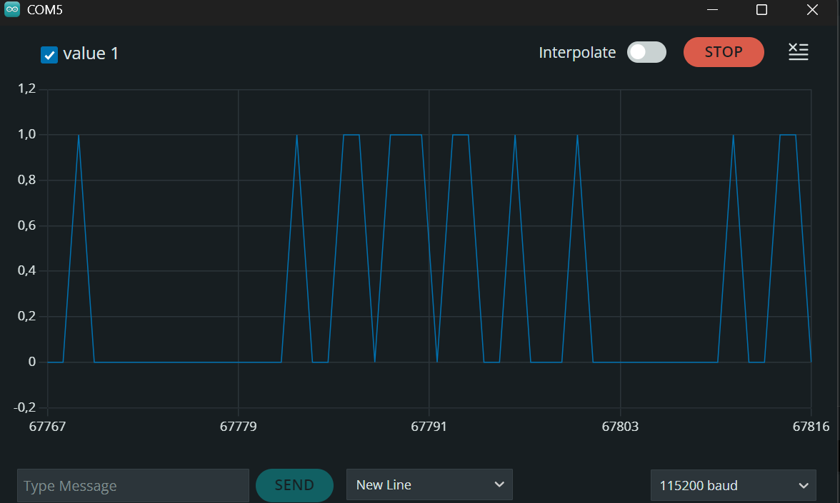

Screenshot of plots of moving backward:
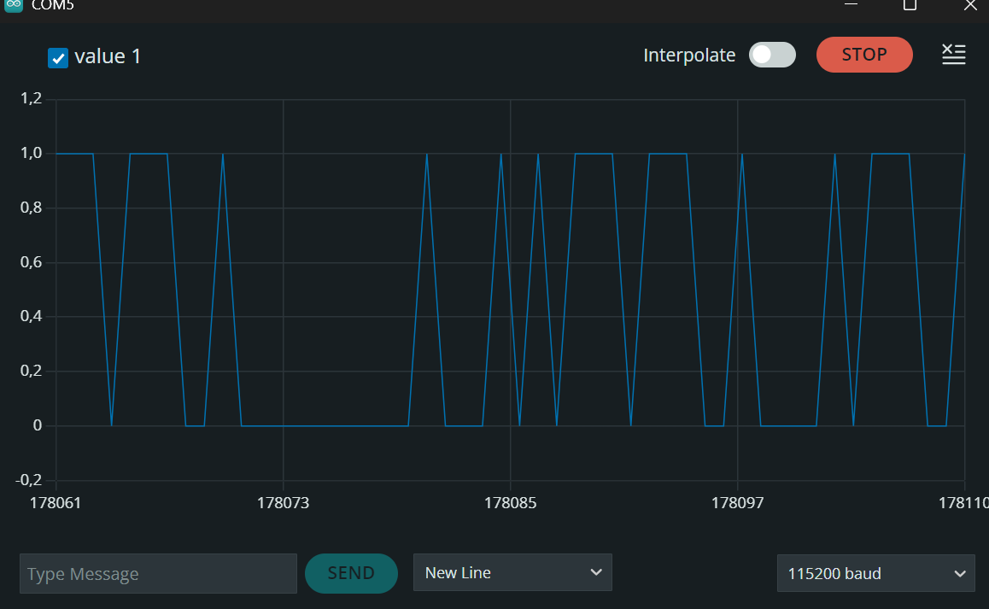

Screenshot of plots of turning right:

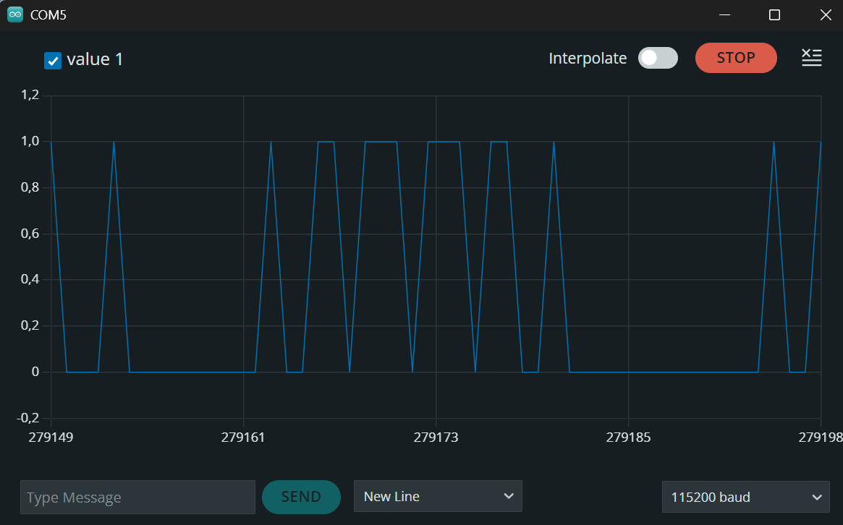

Screenshot of plots of turning left:
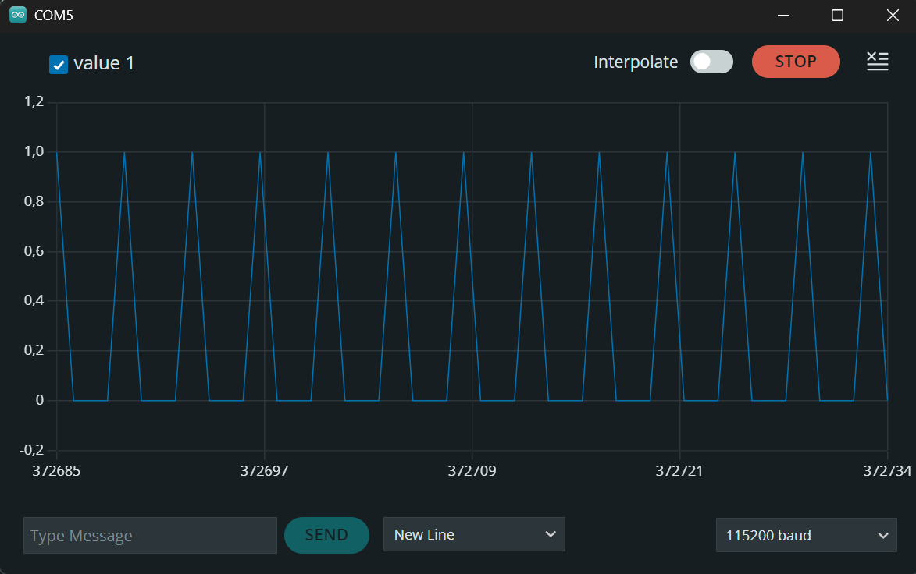

Screenshot of plots of stopping:

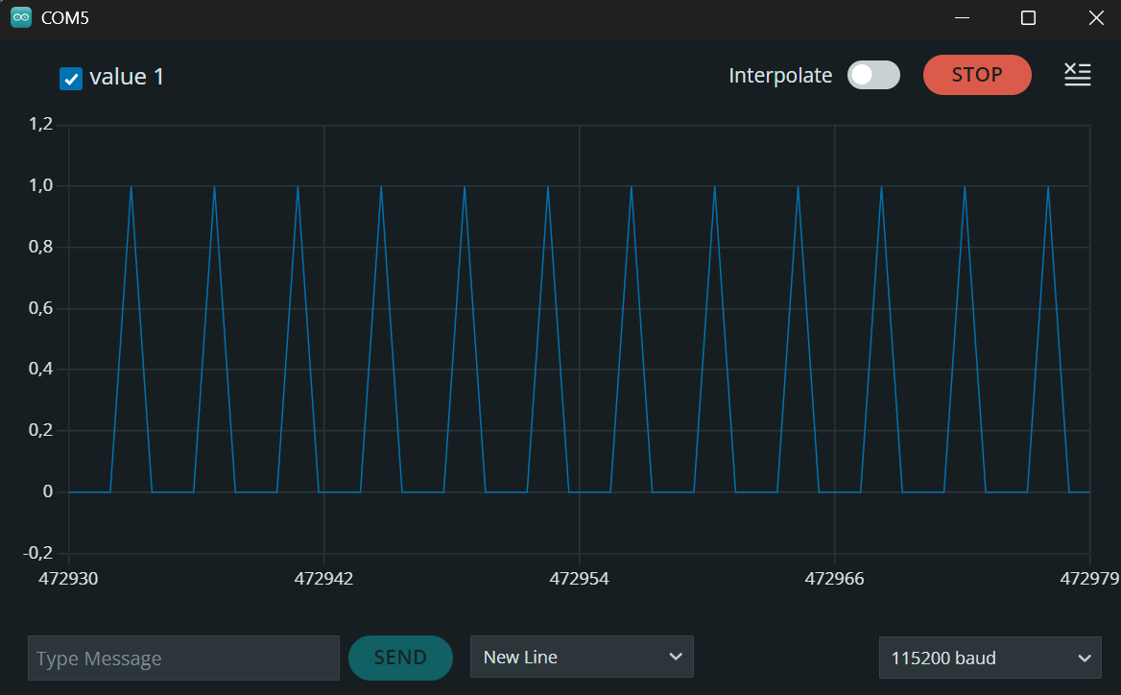

Please commit and push the modified codes to GitHub.
Fill the answer sheet and submit to Canvas/Assignments/Lab5_Answer sheet.

